**Ideation Phase**

**Brainstorm & Idea Prioritization Template**

|  |  |
| --- | --- |
| Date | 08 September 2022 |
| Team ID | PNT2022TMID41225 |
| Project Name | Project – Global sales data analytics |
| Maximum Marks | 4 Marks |

**Brainstorm & Idea Prioritization Template:**

Brainstorming provides a free and open environment that encourages everyone within a team to participate in the creative thinking process that leads to problem solving. Prioritizing volume over value, out-of-the-box ideas are welcome and built upon, and all participants are encourage to collaborate, helping each other develop a rich amount of creative solutions.

Reference: <https://www.mural.co/templates/empathy-map-canvas>

**Step-1: Team Gathering, Collaboration and Select the Problem Statement**

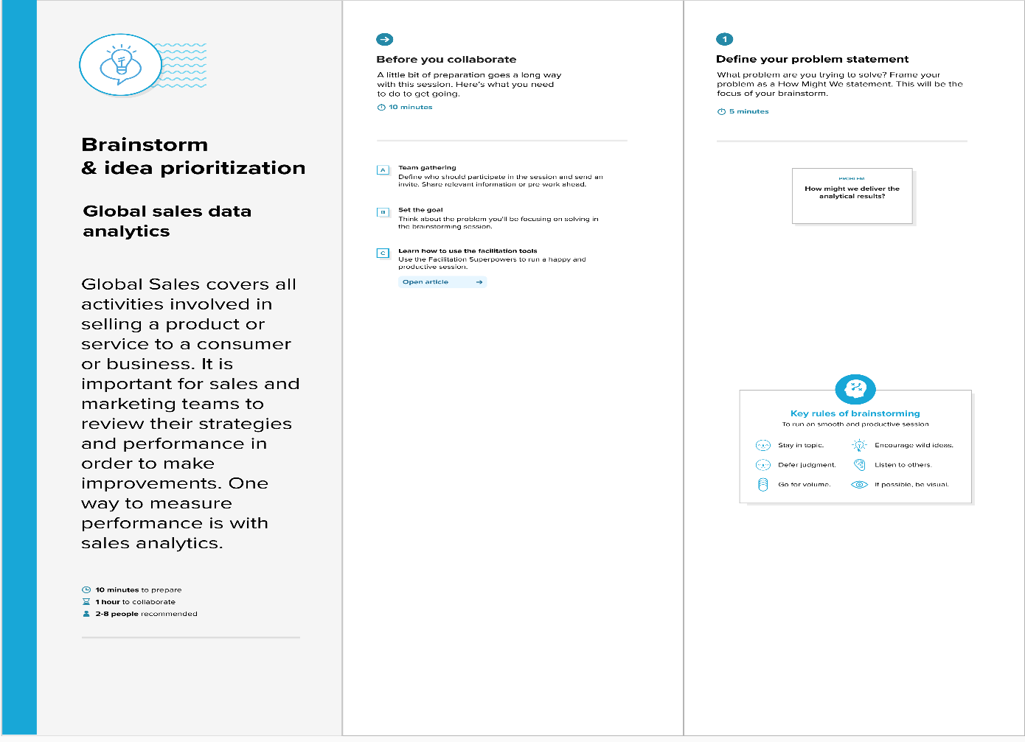

**Step-2: Brainstorm, Idea Listing and Grouping**

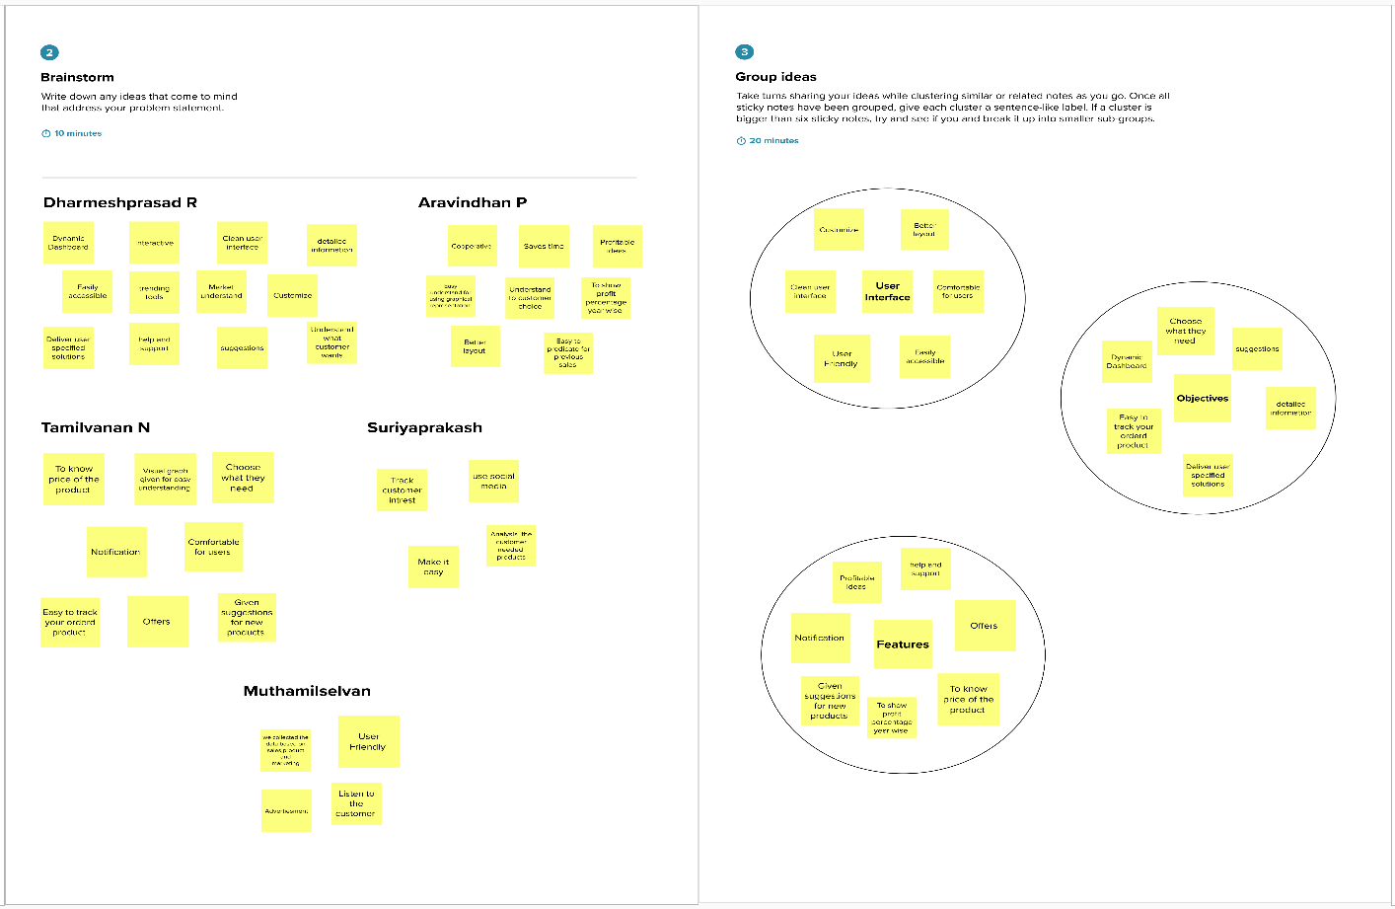

**Step-3: Idea Prioritization**

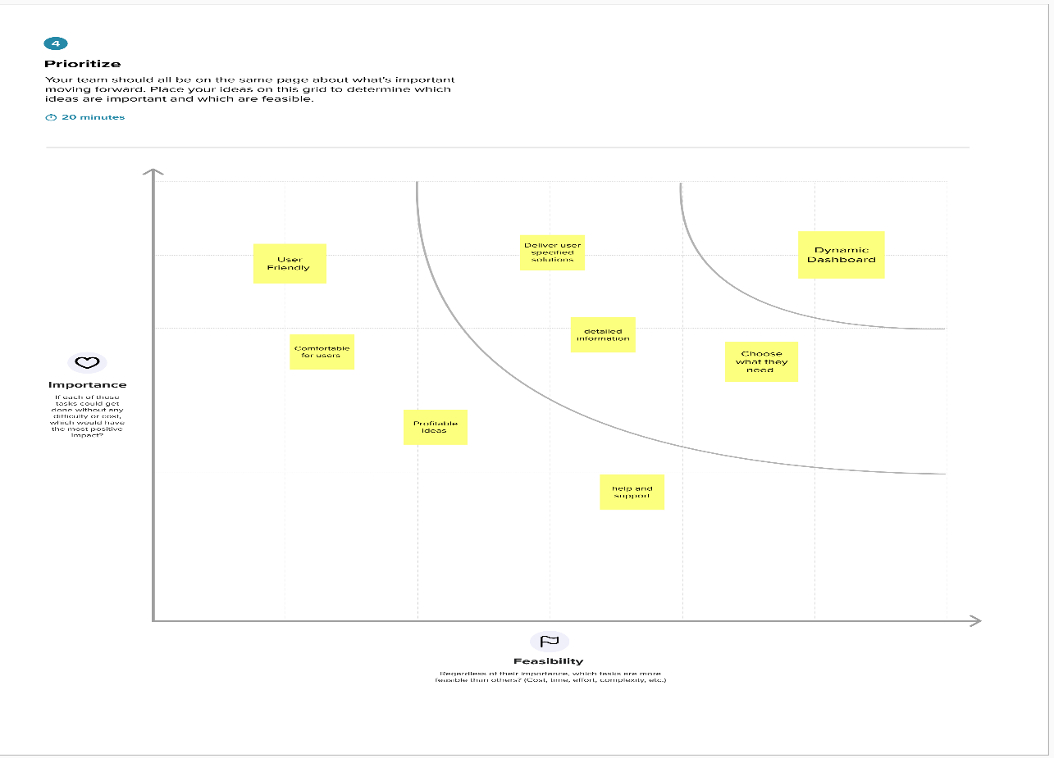

[**Link**](https://app.mural.co/t/ibmproject2614/m/ibmproject2614/1664356820621/f98929b2e51a749b97c8352197b9b23594fc6c02?sender=ucf41b652dd41ec2cbaa57561)